PHASE III
Project Design

Team ID | SWTID-2026-5863
Project Name | AI BLOGNEST API

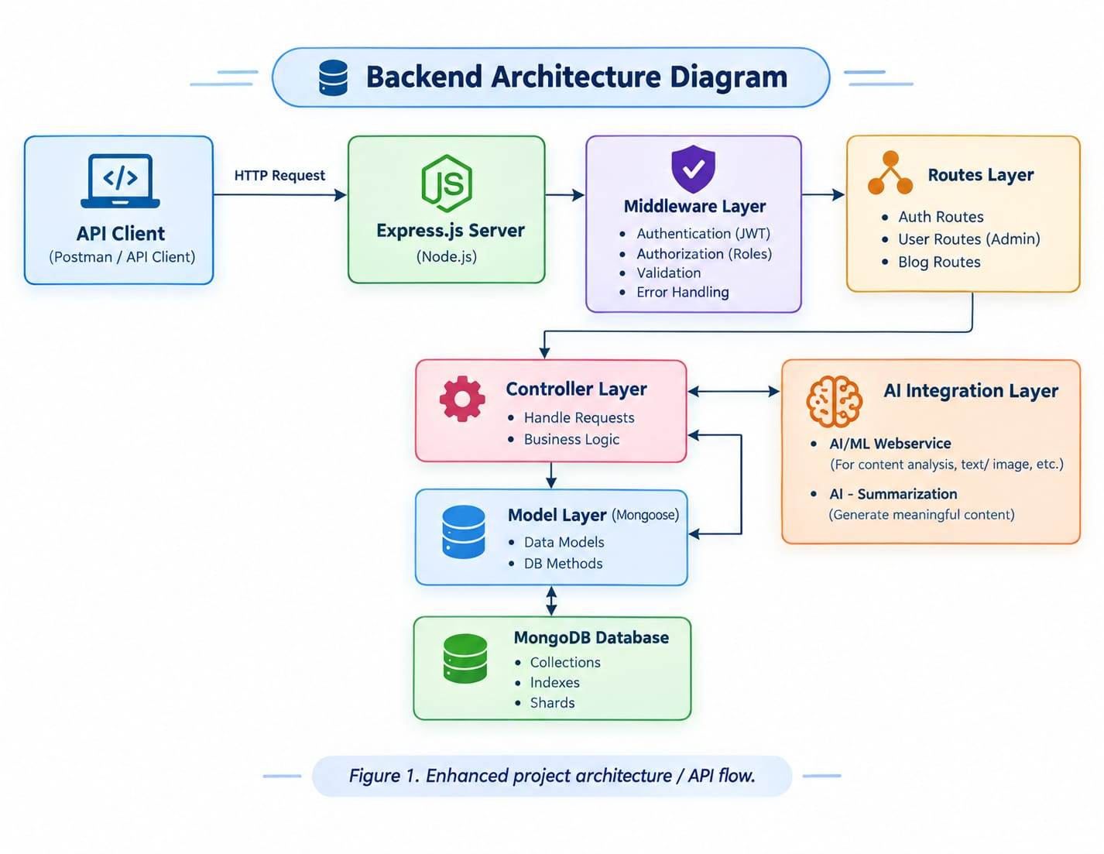
System Architecture Diagram

The backend follows a clean, layered REST architectural pattern to handle incoming requests securely and efficiently.
- API Client / Postman: Initiates HTTP requests with payloads and headers.
- Express.js Server: Acts as the primary application gateway parsing JSON data and handling CORS.
- Middleware Layer: Intercepts requests for authentication (JWT), role verification (RBAC), validation, and error handling.
- Routes & Controller Layers: Route handlers direct traffic to controllers which execute core business logic.
- Model Layer (Mongoose): Manages schemas and connects application logic to MongoDB.
- AI Integration Layer: Communicates with external AI services to handle automated blog drafting and content summarization.

Entity-Relationship (ER) Model &
Database Schema

The database is structured around logical relationships between users, blog posts, categories, and comments using MongoDB and Mongoose.

- User Entity: Contains _id (Primary Key), name, email, password (hashed), role (admin/reader), and timestamps.
- Blog Post Entity: Contains _id, userID (reference to User), title, slug, photo, message (content), likes, and timestamps.
- Category Entity: Contains _id, name, slug, description, and timestamps.
- Comment Entity: Contains _id, postID, userID, content, status (active/flagged), and timestamps.

Key Relationships:

- User to Blog Post: One-to-Many (One user can create multiple blog posts).
- Category to Blog Post: Many-to-One (One category belongs to multiple posts, or posts belong to a category).
- Blog Post to Comment: One-to-Many (One blog post can have multiple comments).
- User to Comment: One-to-Many (A user can write multiple comments).

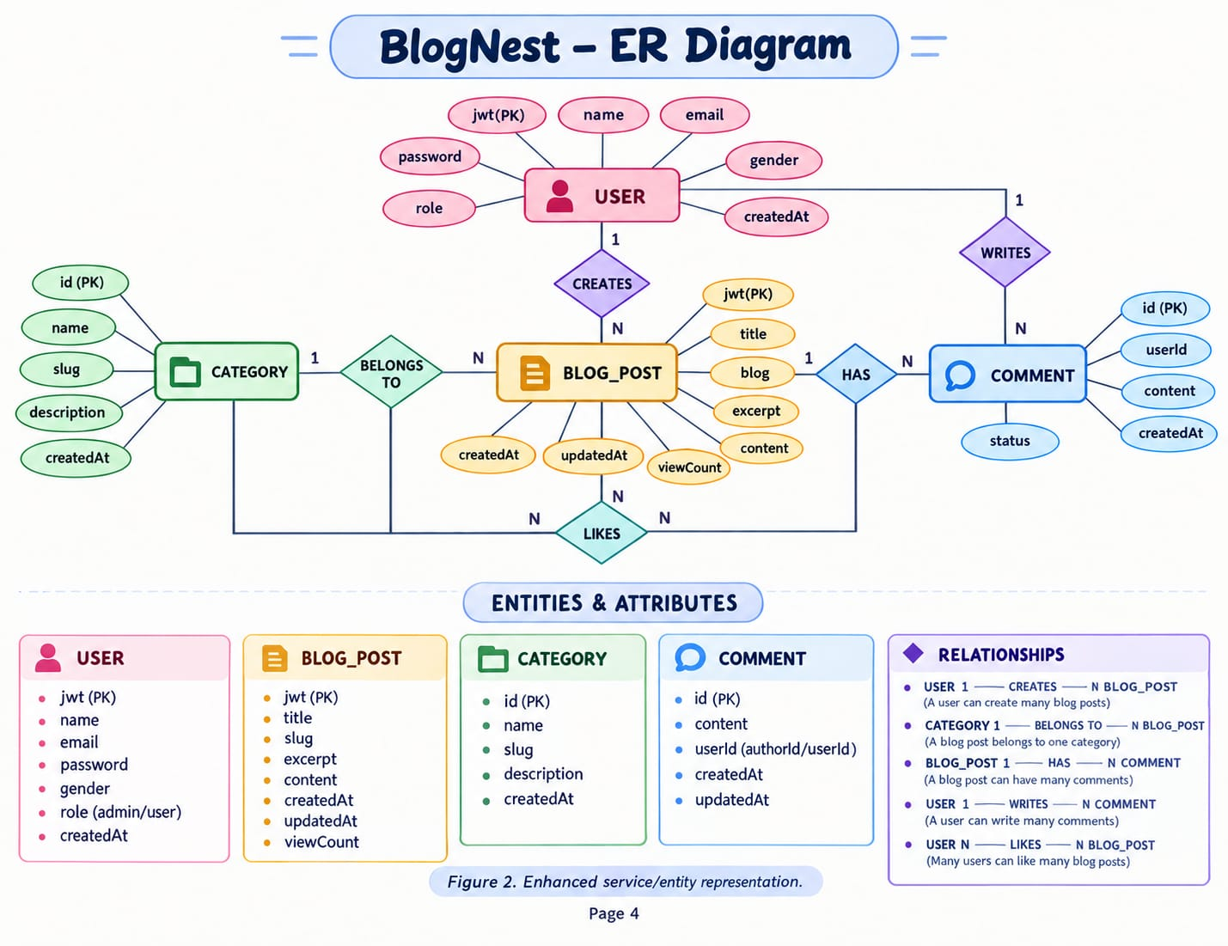

Authentication & User Flow Diagram

The API execution flow handles client requests through a secure stateless pipeline:

- API Request: Sent from client.
- Authentication: Validates email and password against the user collection.
- JWT Generation: Issues a secure stateless token upon successful login.
- Token Verification: Protects subsequent routes by verifying authorization headers.
- Role Branching (User vs. Admin): Directs traffic to standard CRUD operations or administrative tools (including AI generation and content quality audits).
- Database Operations: Executes queries against MongoDB and returns structured JSON responses.

AI-Blog User Flow Diagram
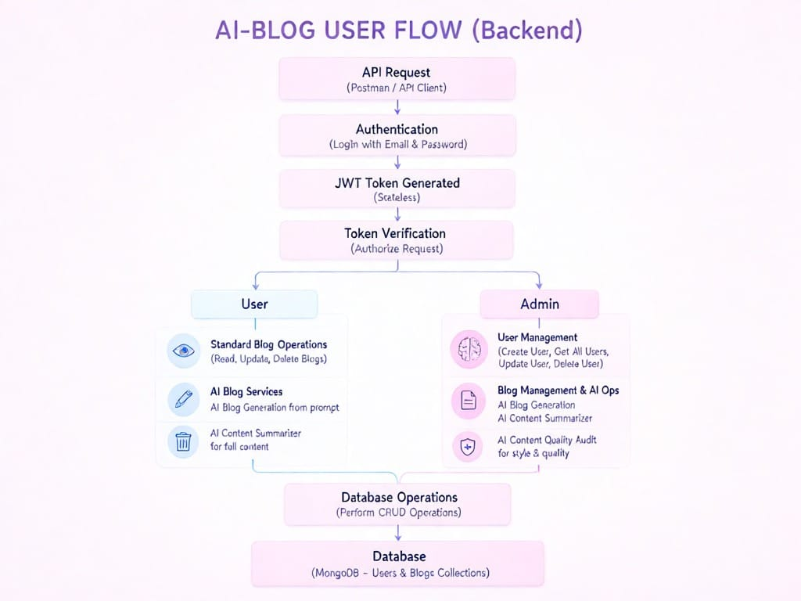

MVC / Architectural Design Pattern

Although headless, the backend maps cleanly to the Model-View-Controller paradigm where the View is replaced entirely by the API routing layer. The Model handles data definitions, the Controller contains execution logic, and the Routing Layer acts as the interface between HTTP requests and controllers.
